Adventures with Purpose--
Pearl River Delta: Hong Kong, Macau & Guangdong

“Quest for Harmony”

Richard Bangs’ Adventures with Purpose—The Pearl River Delta: Hong Kong, Macau, and Guangdong, a new one-hour special from American Public Television, will air on _________ (station) _________________ at (time) _______, (day) __________ (date) _________. Hosted by Richard Bangs who is often called “the father of modern adventure travel,” The Pearl River Delta: Quest for Harmony is the latest documentary in a series of adventure travel, eco-conscience, and historical specials. According to Bangs, “Adventures with Purpose not only quicken the pulse and fire the synapses, they are also journeys of enlightenment and discovery—odysseys that make a difference.”
Adventures with Purpose is produced by Small World Productions of Seattle. The hour-long documentary specials are co-produced by KCTS/Seattle, and Richard Bangs Productions of Marina del Rey, California. KCTS is the presenting station to APT-Exchange, the national distributor.

Whether or not we name it, we all seek a balance among the moving parts of our lives. We strive for agreement between our physical and spiritual worlds. Yet too often we find ourselves incapable of summoning this state of being. Why?

There is a place whose people have been on a never-ending quest to achieve a concord between life’s jagged puzzle pieces. And some believe they have found its secrets.

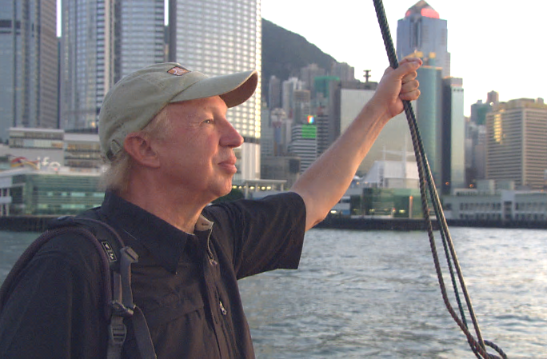

Hong Kong, Macau and Guangdong: three pearls in one exquisite setting. Each is distinct yet they are bound together by a cultural veneration of harmony. According to Richard, “Just as a wick needs a flame, some of us can’t live without exploring our existence, and I inevitably find myself turning to the East and the wisdom of the Ancients.” So once again, Richard is pulled back to China and the Pearl River Delta in search of the roots of the human desire for harmony.

Harmony implies balance and the ability to integrate different elements into a pleasing unity. It incorporates the Chinese concept of Yin/Yang—opposite forces that come together to form a whole.

Chinese philosophers and religious leaders have long honored harmony as an ideal. Confucius, the great Chinese thinker, spoke of "harmony without uniformity." He taught that the world is full of differences and contradictions, but that righteous people should try to balance them to achieve a vital equilibrium.

Taoists believe that by following practices that achieve balance in daily life, they gain harmony with the universe. And the Buddha said that for the enlightened one, harmony is his joy, his delight and his love.

Today we see this fundamental value represented in so many different ways. In this trilogy of spaces Richard looks at how the people of the Pearl River Delta seek harmony in this age.
Adventures with Purpose--
Pearl River Delta: Hong Kong, Macau & Guangdong

In Hong Kong we’ll discover how the rounded shoulders of tradition find poise and meaning with the new and modern. In Macau we’ll explore how western sensibilities integrate with eastern aesthetics. And in Guangdong we’ll look at how some today are rediscovering ancient attitudes about integrating human workings with the natural world.

Richard’s quest begins in Hong Kong, Asia’s world city. At its most authentic, Hong Kong projects an energetic duality—what Richard calls, “An ambition of opposites in concert, the special ingredients of harmony.”

A mere 40 miles from Hong Kong by ferry, Macau shares the shores of the Pearl River delta but seems half-a-world away. Richard’s quest takes him to historic Old Town, Senado Square, the ruins of St. Paul’s Church, Colane Island and the Cotai Strip to learn what role harmony plays in Macau’s success.

To complete his journey Richard travels on to Guangdong Provence. How does Guangdong balance its bursting commerce and industry with the serenity and integrity of its original landscape? To find out, Richard explores Nan Hau Buddhist Temple, ancient Zuhji Lane, the village of Bebei Yao Fastness and Guangdong’s Grand Canyon. But the highlight of his journey is Guangdong’s UNESCO World Heritage Site, a ‘great sculpture garden of scenic wonders’ clustered around Danxia Mountain.

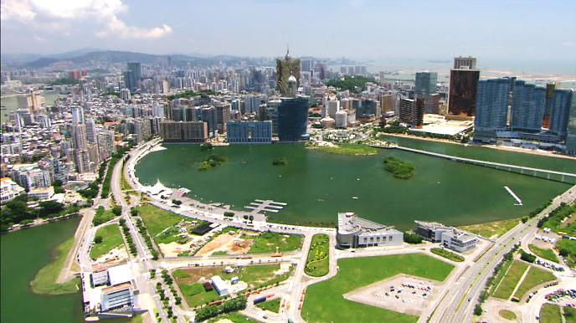
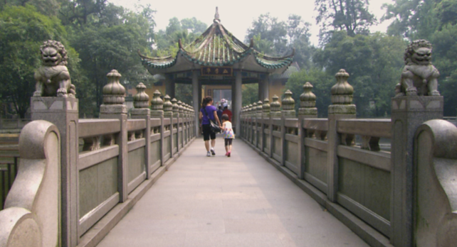
Host and co-executive producer, Richard Bangs is a pioneer in travel-that-makes-a-difference, travel-with-purpose. He has spent more than 30 years as an explorer and communicator, and along the way led first descents of 35 rivers around the globe, including the Yangtze in China and the Zambezi in Southern Africa. Richard has published more than 1000 magazine articles, 18 books, a score of documentaries and CD-ROMs; and has lectured at the Smithsonian, the National Geographic Society, the Explorers Club and many other notable venues. He writes feature articles for the Huffington Post. His latest books include Adventures with Purpose, Quest for Kaitiakitanga, Quest for the Sublime and Quest for the Kasbah, companion books for episodes in the television series.

Richard’s books and DVDs of Adventures with Purpose—The Pearl River Delta: Hong Kong, Macau, and Guangdong are available from Small World Productions. Each DVD contains the complete show and more than an hour of value-added bonuses including never-before-seen footage, and behind-the-scenes glimpses. DVDs are $24.95 each plus shipping. Richard’s Adventures with Purpose books are $16.95 each plus shipping. Books include essays by Richard on a number of destinations. The book and DVD together are $35.95 plus shipping. Viewers may order online at www.AdventuresWithPurpose.TV or call the order desk at 800.866.7425.

Adventures with Purpose--
Pearl River Delta: Hong Kong, Macau & Guangdong

Adventures with Purpose—The Pearl River Delta will be up-linked on APT’s HD satellite transponder. HD and standard definition “letterboxed” versions of the documentary will air on hundreds of public TV stations nationwide. Digital audio is transmitted in stereo.

American Public Television (APT) has been a leading distributor of high-quality, top-rated programming to America’s public television stations since 1961. Since 2004, APT has distributed approximately half of the top 100 highest-rated public television titles. Among its 300 new program titles per year are prominent documentaries, news and current affairs programs, dramatic series, how-to programs, children’s series and classic movies, including For Love of Liberty: The Story of America’s Black Patriots, A Ripple of Hope, Rick Steves' Europe, Newsline, Globe Trekker, Simply Ming, Travelscope, America's Test Kitchen From Cook’s Illustrated, Lidia's Italy, P. Allen Smith's Garden Home, Murdoch Mysteries, Doc Martin, Rosemary & Thyme, The Rat Pack: Live and Swingin’, Johnny Mathis: Wonderful, Wonderful! and John Denver: The Wildlife Concert. APT also licenses programs internationally through its APT Worldwide service. In 2006, APT launched and nationally distributed Create® – the TV channel featuring the best of public television's lifestyle programming. APT is also a partner in the WORLD™ channel expansion project including its web presence at WORLDcompass.org. For more information about APT’s programs and services, visit APTonline.org. For more information on Create, visit CreateTV.com.

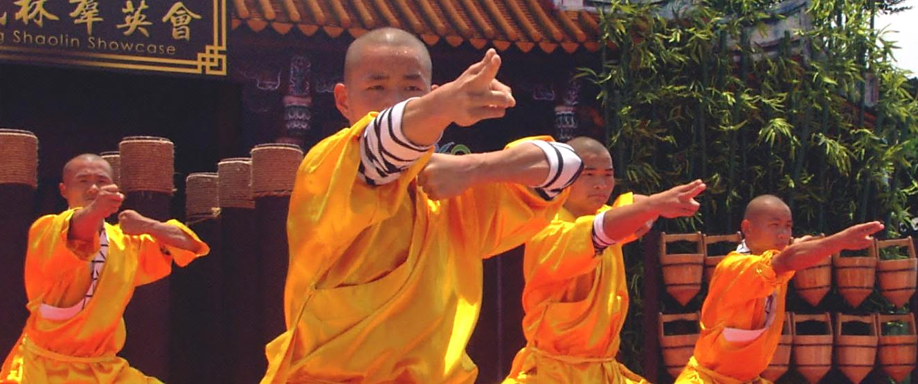
Underwriting provided in part by Cathay Pacific Airways.

Richard Bangs’ Adventures with Purpose
The Pearl River Delta: Hong Kong, Macau & Guangdong

Co-produced by
| Small World Productions | KCTS/ Seattle |Richard Bangs Productions |

| Small World Productions | 140 Lakeside Avenue | Suite 200 | Seattle WA 98122 |
|www.AdventuresWithPurpose.TV | 206 329 7167 | johngivens@travelsmallworld.com |

